Recursion in python
Recursion is the process of defining something in terms of itself.
Python Recursive Function
In Python, we know that a function can call other functions. It is even possible for the function to call itself. These types of construct are termed as recursive functions.
Example:
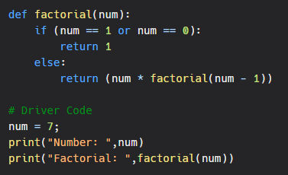
Output:
